**Lightning Network**

Useful Info About the Lightning Network:

* The number of channels advertised by our Node is **19584.**
* Opening Channel Cost: the funding transaction fee is between **0.01 and 0.02 $ = 0,0088 and 0,018 Euro**
* **There is no limit on the number of channels a node can accept.** The only limitation is on the number of “pending channels” (still unconfirmed) that can be accept at the same time.
* Our node has seen as **higher value of channel capacity  0.1678 BTC (536,16 Euro) and as lower value 0,0000105 BTC  (0,034 Euro).**
* On a payment failure:
  + **No fee are charged**: The fees are part of the onion routing package within the HTLCs. So a routing node accepts an incoming HTLCs and forwards it if there is a difference in value that can be collected as fees. The HTLCs are conditional payments on the condition that the preimage is delivered in return. This will only happen after a path of HTLCs is successfully established. If a payment fails some node can't forward the HTLC which means that no one along the path will be able to settle the HTLCs. This in turn means no fees are being paid.
  + (See more in the attached payment error log) **Is possible to identify:**
    - **Erring Node**
    - **Erring Channel**
* **All the graphic are expressed in millisathoshi (msat) .  
  Value : 1msat= 0.00000000001 BTC = 0,000000005 EUR**
* **1 EUR = 31407000 msat**
* **More info about fees.**We have 2 type of fees:
  + fee_base_msat: Minimum accepted fee regardless the effective value of money transferred.
  + fee_proportional_millionths: Fee for every unit of coin transferred.
* The final fee is calculated as follow:   
  **Fee= fee_base_msat + ( amount_to_forward * fee_proportional_millionths / 1000000 )**
* **Paying a coffe 1 Euro will cost:** 
  + **Best case:** 
    - **Fee_base_msat= 1**
    - **Amount_To_forward= 31407000 msat = 1 Euro**
    - **Fee_proportional_millionths=1**
    - **Fee=1 + (31407000* 1/1000000) = 32,407 msat = 0,000000157035 Eur**
  + **Mean Case:** 
    - **Fee_base_msat= 1500**
    - **Amount_To_forward= 31407000 msat = 1 Euro**
    - **Fee_proportional_millionths=500**
    - **Fee=1500 + (31407000* 500/1000000) = 17203,5 msat = 0,0000860175 Euro**
  + **Worst Case:**
    - **Fee_base_msat= 10000**
    - **Amount_To_forward= 31407000 msat = 1 Euro**
    - **Fee_proportional_millionths=5000**
    - **Fee=10000 + (31407000* 5000/1000000) = 167035 msat = 0,000835175 Euro**
* **The htlc_minimum_msat** parameter:   
  Is the minimum amount of coins accepted when a node1 tries to establish an HTLC with node2. All attempt to establish an HTLC with a value less than htlc_minimum_msat will fail.

**Capacity Distribution:**   
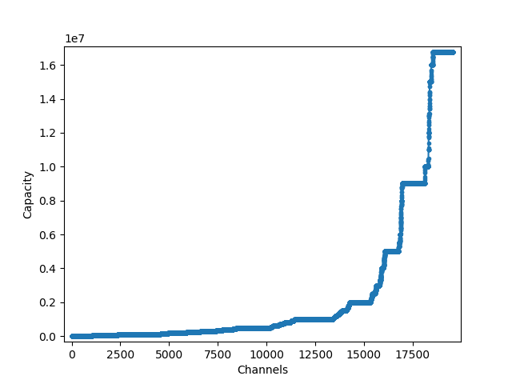

**Fee base msat distribution for origin nodes:** 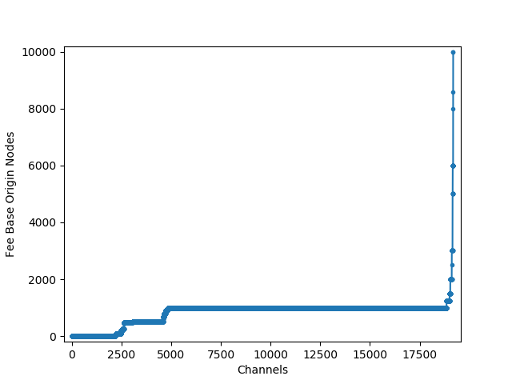

**Fee base msat distribution for destination nodes:**

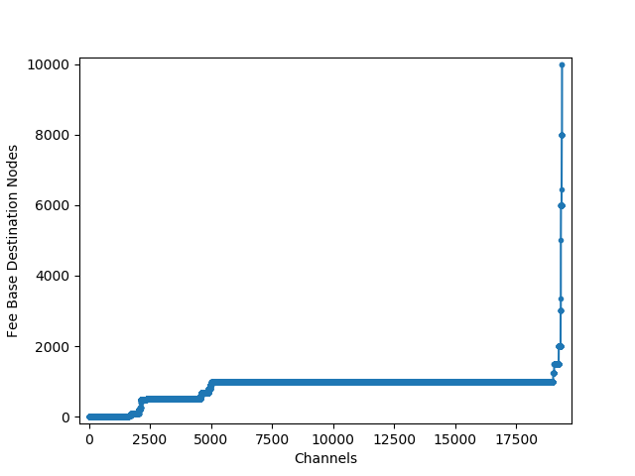

**Fee proportional millionths distribution for origin nodes**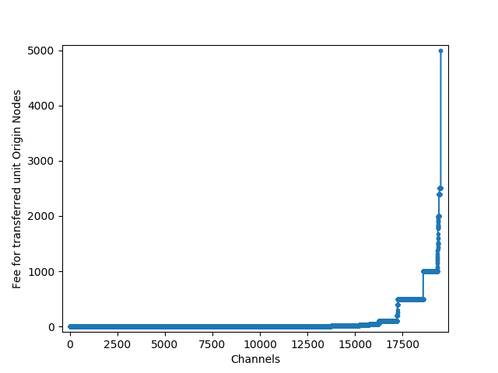

**Fee proportional millionths distribution for destination nodes:**

**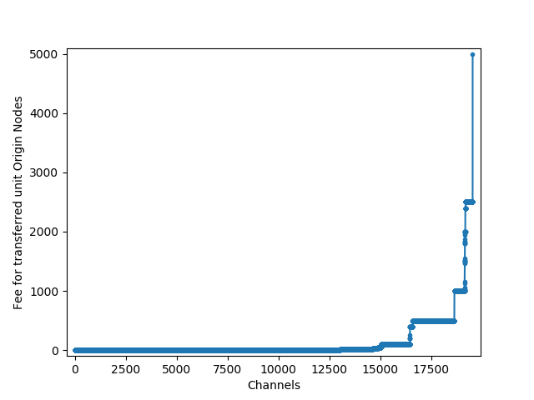  
  
HTLC minimum msat distribution for origin nodes:**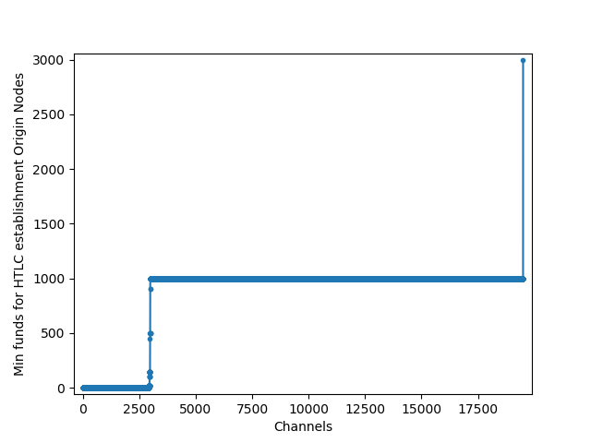

**HTLC minimum msat distribution for destination nodes:**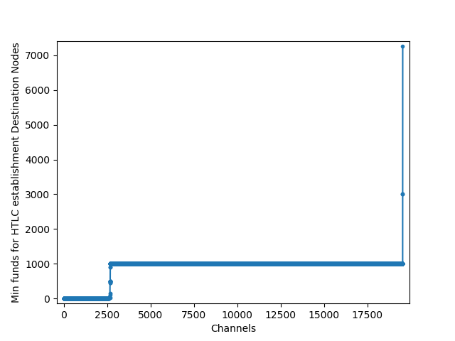

**Correlation Between capacity and fees.**

**Correlation Capacity-Fee_rate_milli plot origin nodes:** 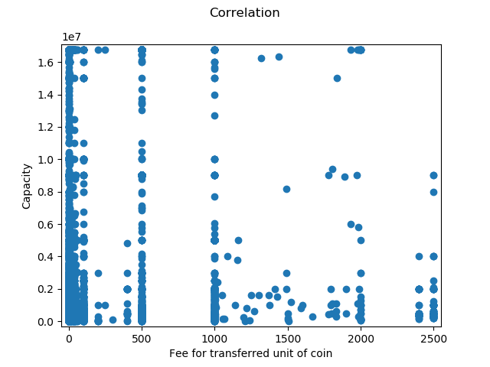

**Correlation density Capacity-Fee_rate_milli plot origin nodes:** 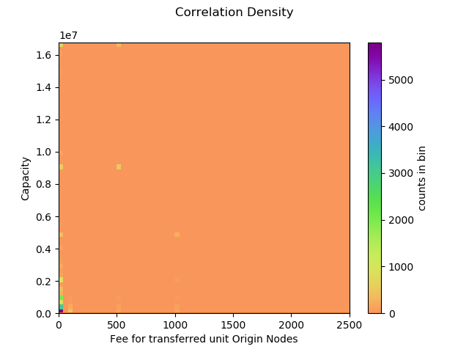

**Correlation Capacity-Fee_rate_milli plot destination nodes:**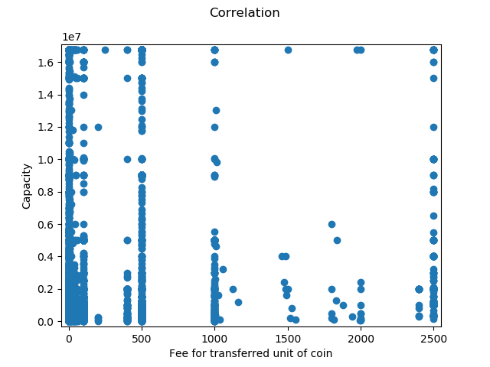

**Correlation density Capacity-Fee_rate_milli plot destination nodes:**

**Correlation Capacity-Fee_base_msat plot origin nodes:**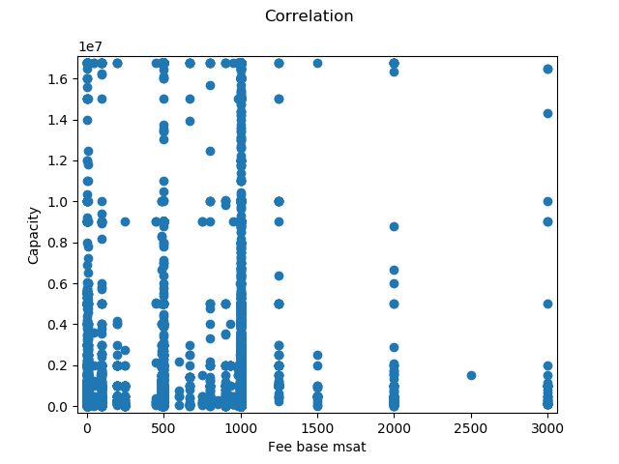

**Correlation density Capacity-Fee_base_msat plot origin nodes:**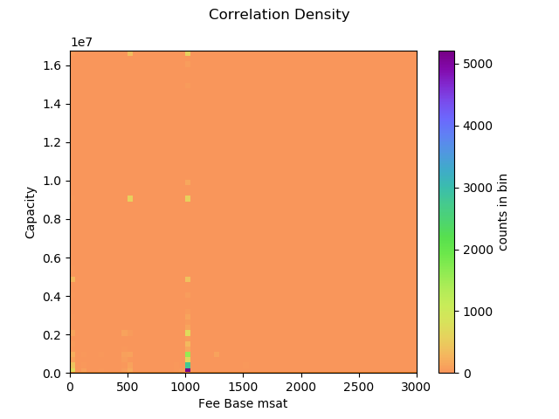

**Correlation Capacity-Fee_base_msat plot Destination nodes:**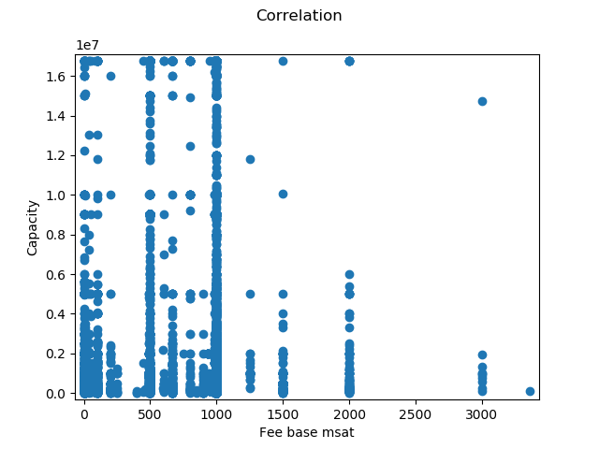

**Correlation density Capacity-Fee_base_msat plot Destination nodes: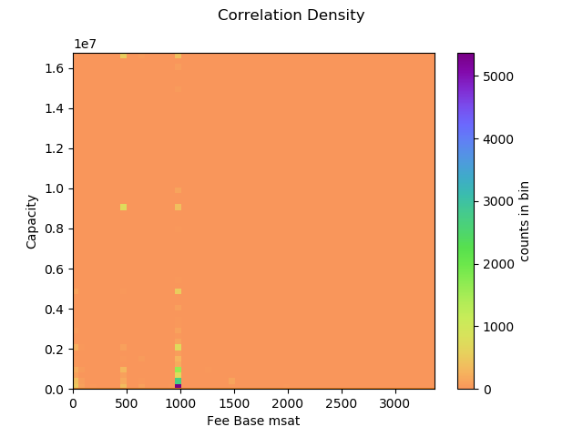Correlation Capacity-Min_HTLC plot origin nodes:**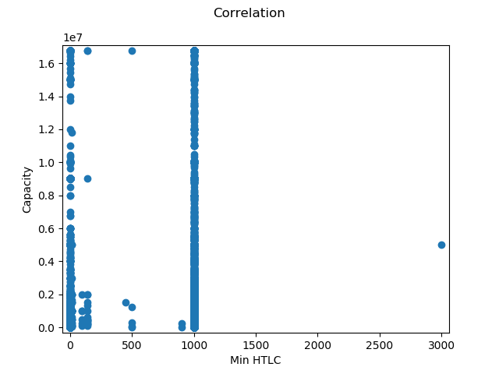

**Correlation density Capacity-Min_HTLC plot origin nodes:**



**Correlation Capacity-Min_HTLC plot Destination nodes:**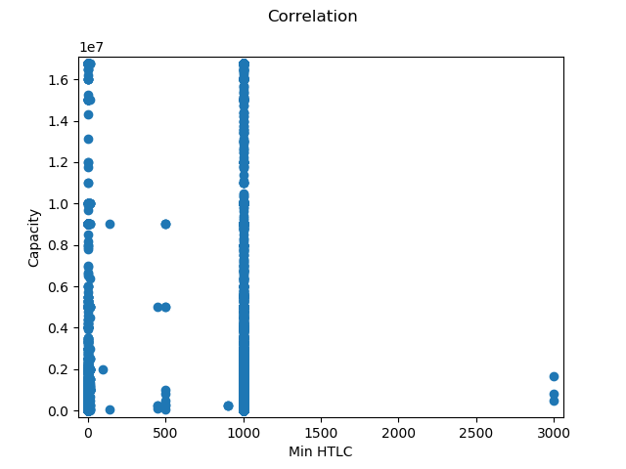

**Correlation Desnity Capacity-Min_HTLC plot Destination nodes**: